|  |  |
| --- | --- |
|  | **Department of Computer Science**  **University of Management and Technology** |

**Assignment Description File**

|  |  |
| --- | --- |
| Course Name: | **Software Engineering** |
| Section: | V-04 |
| Teacher: | **Fasiha Ashraf** |
| Student Name n ID | **Iman Imtiaz (f2022266857)**  **Areesha Noor f2022266674**  **Abdullah Shafqat F2022266675** |
| Assignment No.: | **3** |
| Deadline: | FOLLOW LMS SUBMISSION DEADLINE |

**NOTE: PLAGIARIZED ASSIGNMENT EITHER FROM CLASSMATES OR INTERNET WILL BE MARKED STRAIGHT ZERO.NO ASSIGNMENT WILL BE ACCEPTED AFTER DEADLINE.ALWAYS MENTION SECTION ON ASSIGNMENT**

**FOLLOW THE TEMPLATE ATTACHED. Submit softcopy on LMS**

**Assignment Description:**

****Q1: Data Flow Diagram Level 0 [10]****

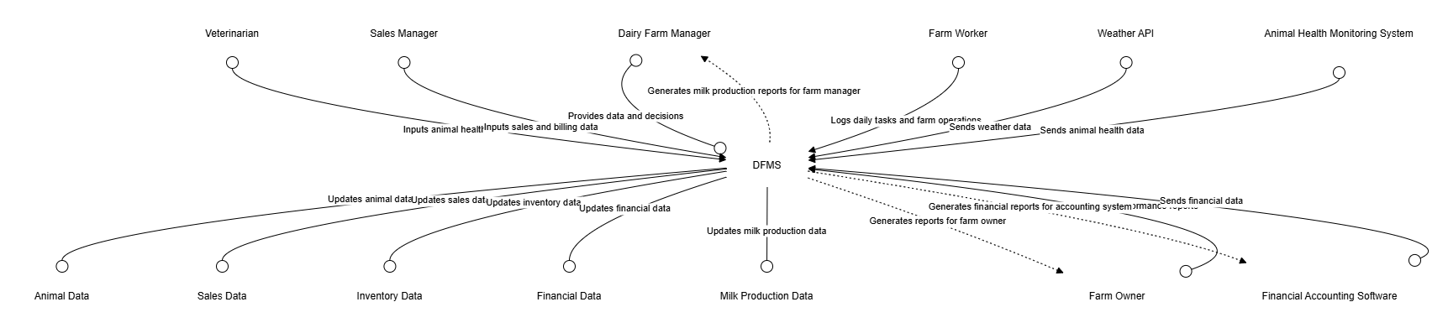

****Q2: Data Flow Diagram Level 1 – 2 [20]****

DFD LEVEL 01 DFMS:

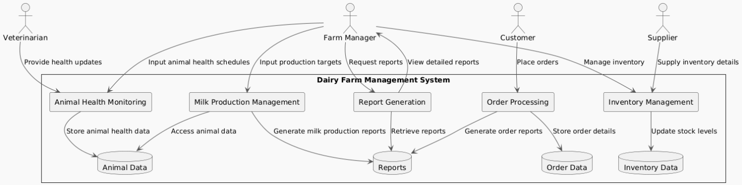

DFD LEVEL 02 DFMS:

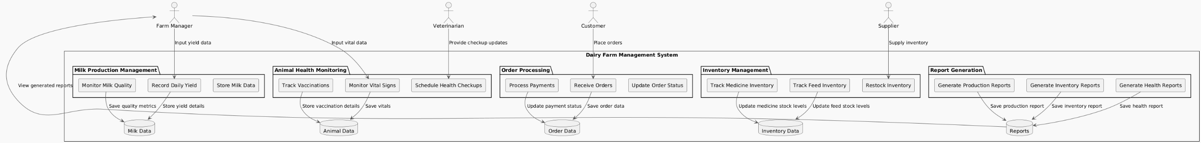

****Q3: Architecture diagram [20]****

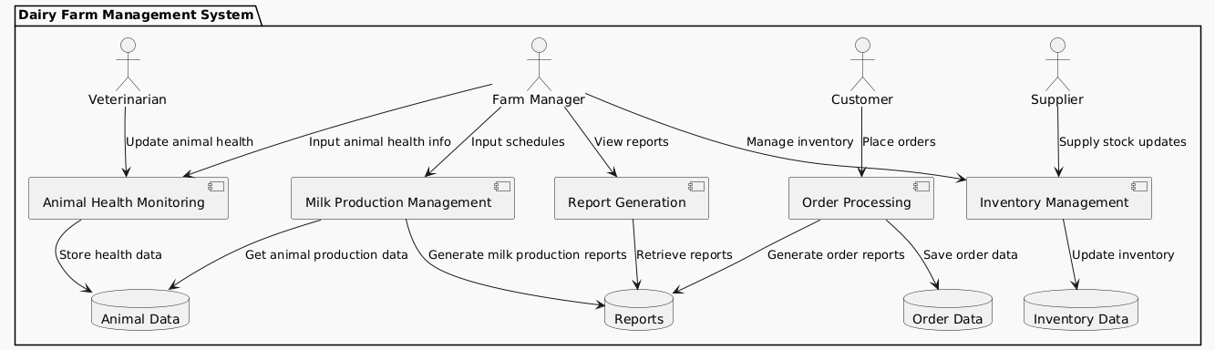

# Data flow diagram (optional)

## Data Flow Diagram Level 0

Identifies sources and sinks only e.g

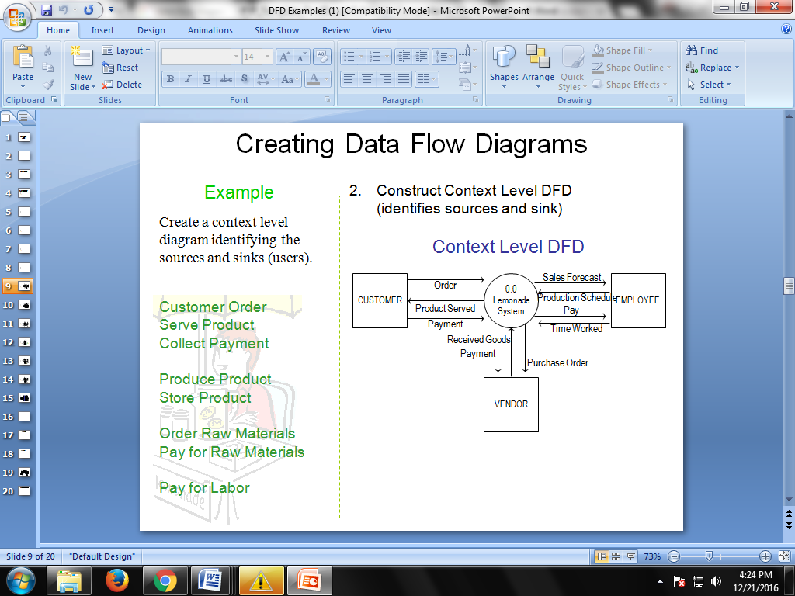

## Data Flow Diagram Level 1

Identifies actual data flows and data storese.g

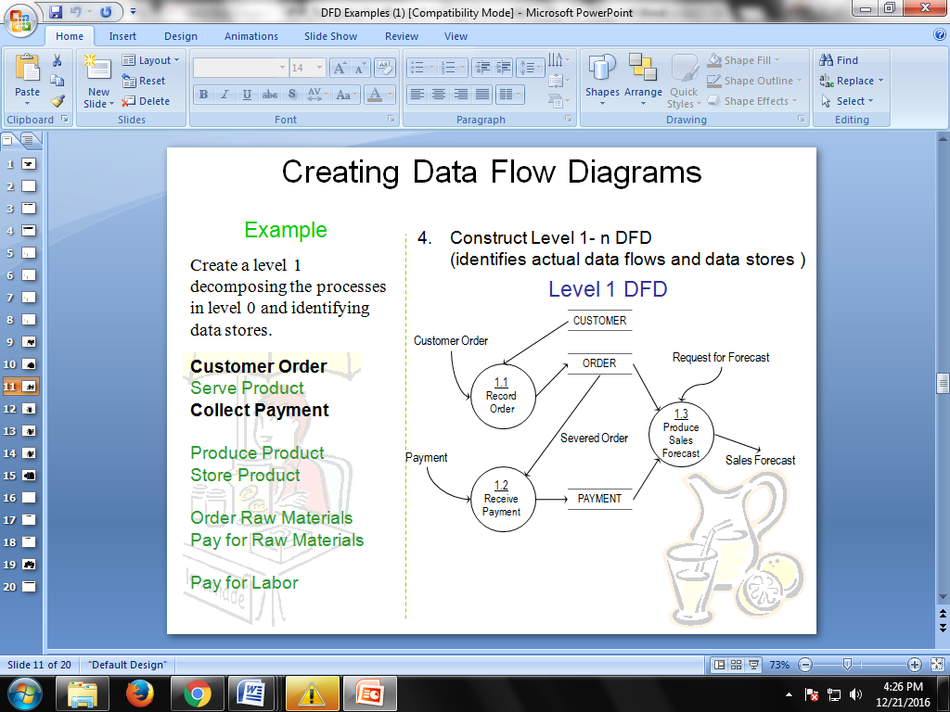

## Data Flow Diagram Level 2

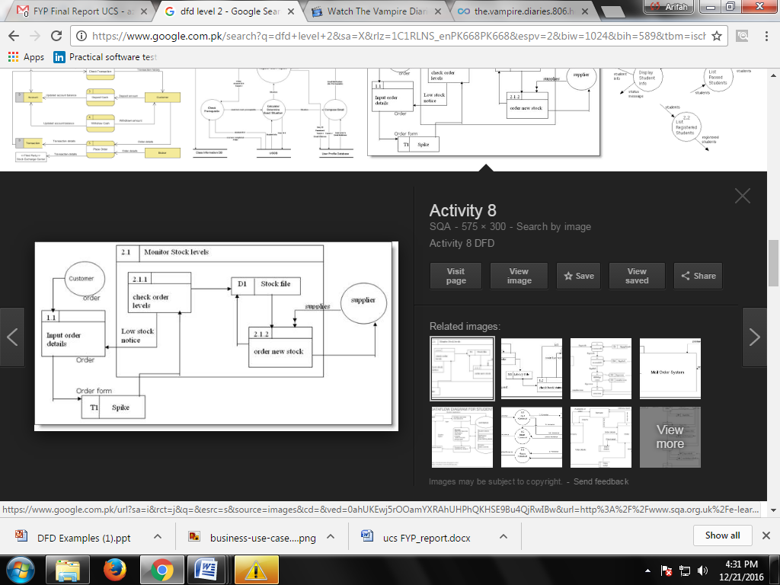

# System Design

Describe the system architecture, or simply provide the architecture diagram. For School system it may include web based front end, webserve , database etc. Don’t worry too much about it just give a simple diagram of a typical web based project.

## System Architecture Diagram



Figure : System Architecture